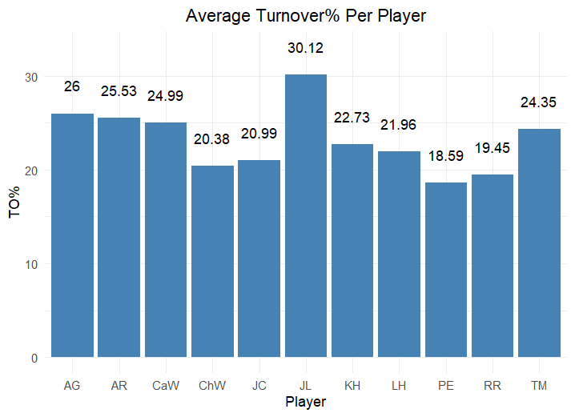

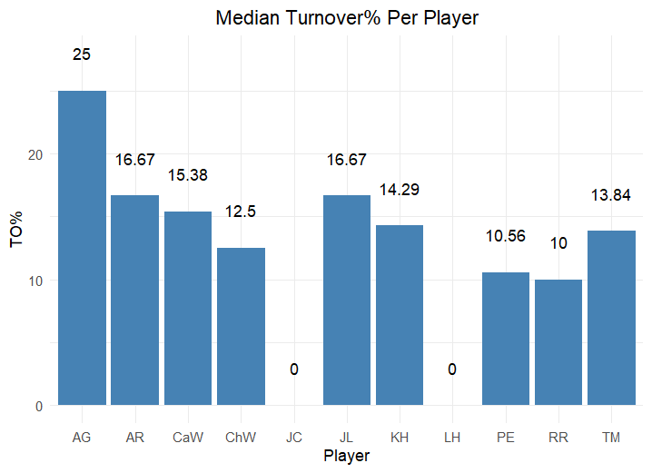

Figure 2: Median Turnover Percentage Across All Lineups a Player Appears In.  
The chart was generated by taking the median TO% across all lineups a player was included in. For example, the average TO% across all lineups that included Addysen Gray (AG) is 25%. Player names are organized across the X-axis in alphabetical order, by initial.

Figure 1: Average Turnover Percentage Across All Lineups a Player Appears In.  
The chart was generated by taking the average TO% across all lineups a player was included in. For example, the average TO% across all lineups that included Addysen Gray (AG) is 26%. Player names are organized across the X-axis in alphabetical order, by initial.

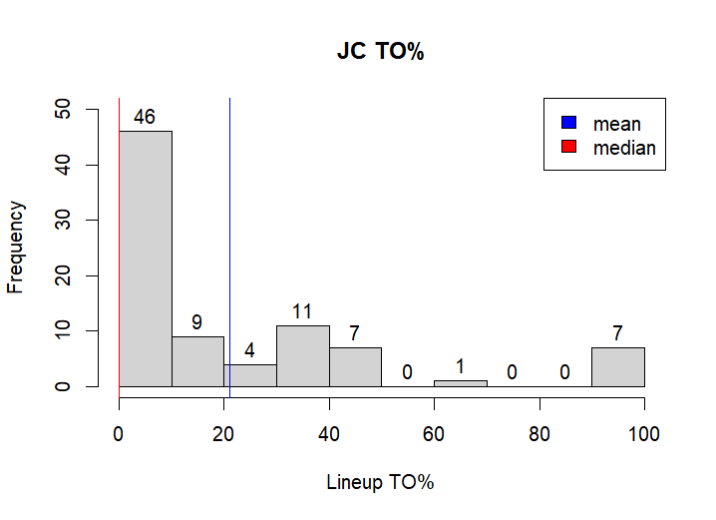

Figure 3: Histogram for JC Turnover Percentage.  
Because JC has a median turnover percentage of 0%, I included the above histogram to show why that is. To read it, 46 lineups that JC is in have a turnover percentage of 0-9.9%, 9 lineups have a turnover percentage of 10-19.9%, and so on. The actual number of lineups that have a TO% of 0 is 44, which is more than half of the total lineups. Thus, the median score is a 0.

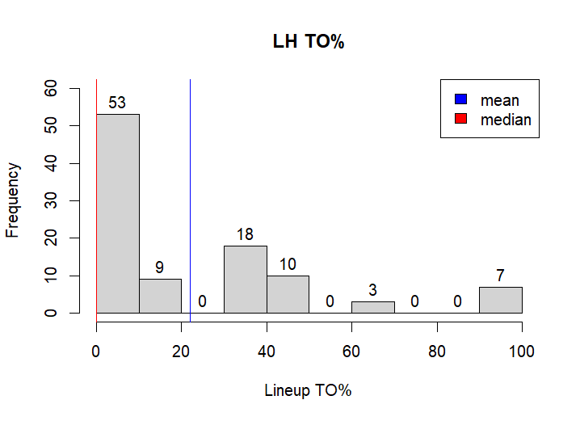

Figure 4: Histogram for LH Turnover Percentage.  
Because LH has a median turnover percentage of 0%, I included the above histogram to show why that is. To read it, 53 lineups that LH is in have a turnover percentage of 0-9.9%, 9 lineups have a turnover percentage of 10-19.9%, and so on. The actual number of lineups that have a TO% of 0 is 51, which is more than half of the total lineups. Thus, the median score is a 0.

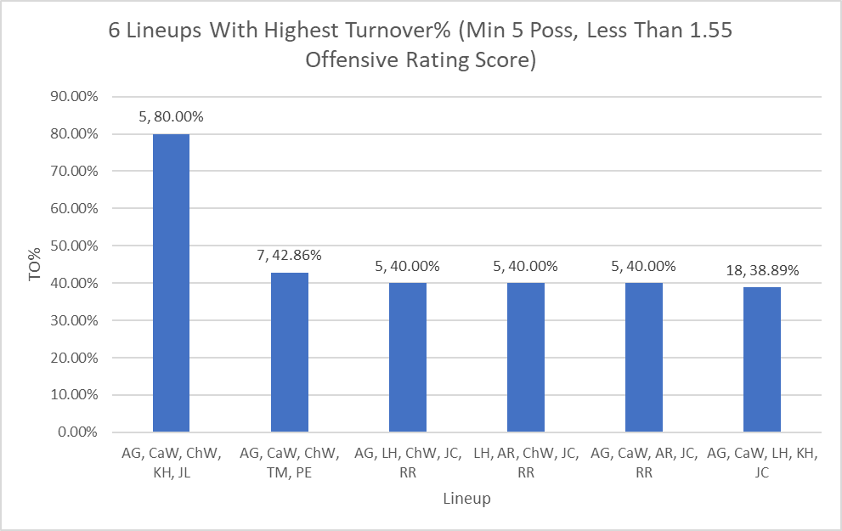

Figure 5: 6 Lineups with the Highest Turnover% with a Minimum 5 Possessions Played and Less than 1.55 Offensive Rating Score.  
The above lineups have the highest turnover percentage for all lineups that have both at least 5 possessions played and a less than 1.55 offensive rating score. Lineups are organized in decreasing TO%, with each lineup on the x-axis and TO% on the y-axis. The 1.55 offensive rating score (ORS) cutoff was chosen due to 1.55 being the current overall team ORS. The number of possessions is the first value above the bar, the second value is the TO% itself.